Roman Britain was part of an empire extending from Europe to north Africa round the Mediterranean, with trade contacts as far as India. Trade brought luxury goods like pepper, olive oil and wine, even rare Chinese silk to Britain. The Romans introduced many new plants and animals, such as cabbages, lettuce, parsley, walnuts, rosemary, peacocks, pheasants and fallow deer.

Farming
The Romans continued to farm the animals which were common in Britain before they arrived: cattle, sheep and pigs. Indeed British cattle were being exported to the Roman Empire before the invasion. We know that two varieties of goats were also kept, for their milk and their meat. The Romans continued to grow crops already cultivated in prehistoric Britain but more land was brought under cultivation. The main crops were wheat, rye and oats. Barley was also grown, for food and for animal fodder.

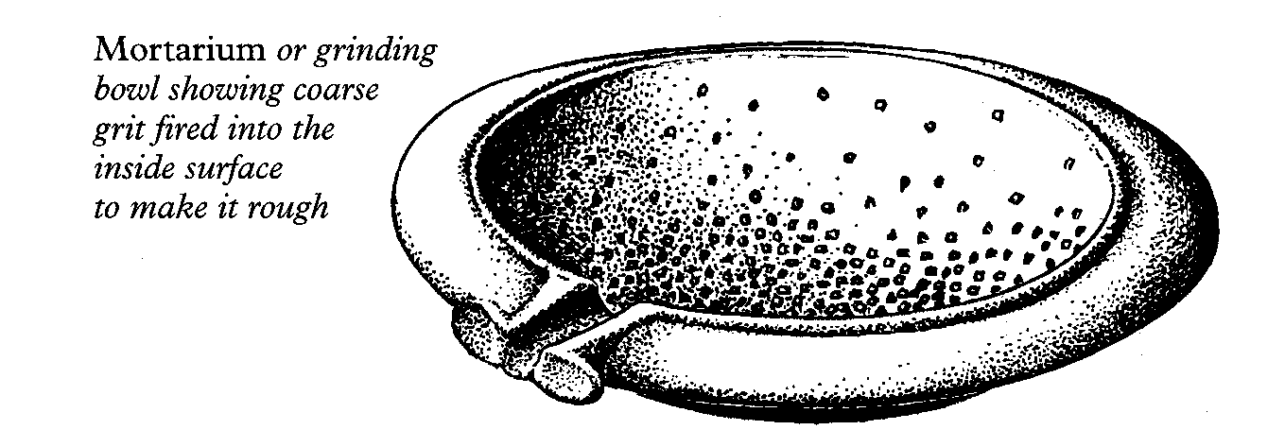

Roman Heslerton
Evidence from soil analysis at Heslerton shows that, during the Roman period the lower slopes of the Wolds, which are on heavier soils, were probably ploughed for the first time, while woodland was cleared on the higher slopes. Perhaps the people had to open up new areas, using improved Roman ploughing technology, to generate the extra produce required to pay Roman taxes or to supply the military garrison and Roman town at Malton. There was little evidence of wild animals or birds at Heslerton, so it is thought that their farming was efficient enough to supply all their needs.

The Roman inhabitants at Heslerton raised both sheep and cattle at the site itself. We also think that they raised sheep on the foothills of the Yorkshire Wolds and that cattle were pastured on the fields of the Vale. Pigs were kept around the houses. Careful examination of the animal bones reveal that some cattle were used to pull ploughs or carts. Sheep were bred for both food and wool.

The people of Heslerton also bred geese and chickens and there was evidence of dogs, cats, horses and mules or donkeys at the settlement.

Food
Although the people who lived in Britain when the Romans invaded may not have changed their diet much, we do know that the Romans imported a different kind of cooking which involved mixing a variety of flavours. They used lots of home-grown herbs and spices imported from the eastern parts of the empire, and beyond. Roman cooks in Britain used specially prepared sauces which they could buy in baulk, imported from the Mediterranean – liquamen, for example, made from salted fish and fish insides left to become liquid in the sun. Modern cooks, wanting to re-create Roman dishes, now use anchovy essence instead.

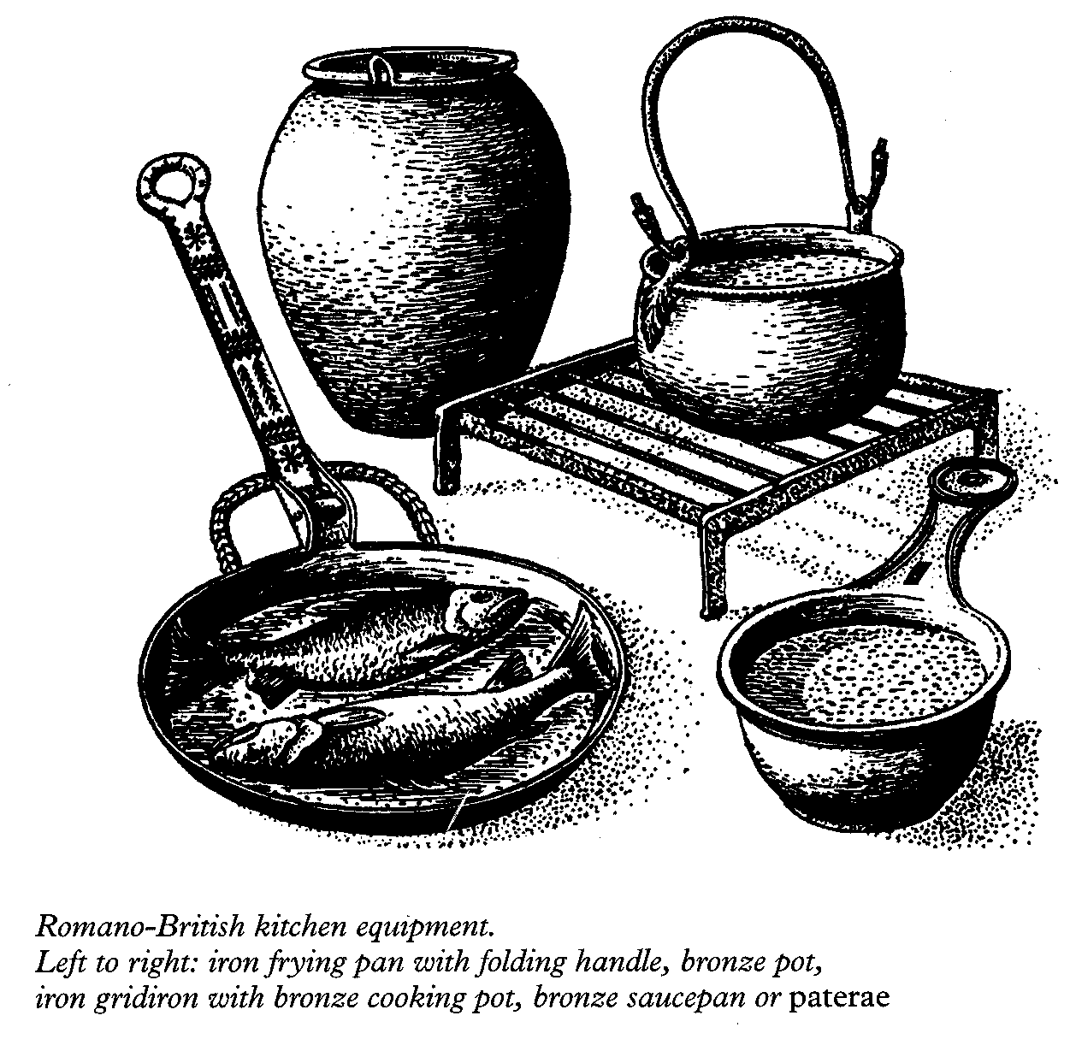

Recipes
We know a lot about Roman cooking and recipes from the cookery book of Marcus Apicius, who lived in the 1st century AD. Some of the recipes given here show how much the Romans loved flavours. Try them at home!

Cabbages with leeks
Put the boiled cabbages into a shallow saucepan and season with liquamen, olive oil, ordinary wine and cumin. Sprinkle with pepper, leeks, caraway seeds and fresh coriander.

Forcemeat sausages
Chop up the meat and pound with white bread without the crust which has been steeped in wine. At the same time pound pepper, liquamen and, if you like, myrtle-berry. Make little forcemeat balls, inserting pine kernels and pepper corns. Wrap in sausage skin and cook gently in caroenum (wine reduced by one third).

Home-made sweets: stuffed dates
Stone the dates and stuff with nuts, pine kernels or ground pepper. Roll them in salt and fry in warmed honey, then serve.

Drawings courtesy of English Heritage
© The Landscape Research Centre 2003

FOOD & COOKING
IN ROMAN
HESLERTON

