Before the end of the 4th century AD, the coasts around Britain were under attack from a number of new invaders. The Irish and the Picts attacked the west and the north. Saxons and other peoples, together known as the Anglo-Saxons, sailed from Europe. Anglo-Saxon is the name we now use for several different peoples: Angles, Saxons and Jutes from northern Germany and Scandinavia; Frisians and Franks from lands which are now part of France, Holland and part of Germany.

By the middle of the 5th century there were Anglo-Saxons settled in the eastern part of Britain, from north of the Humber to the south coast. Gradually, the Anglo-Saxons moved west, driving out the British warlords and, by the beginning of the 6th century, they had settled widely in Britain.

Anglo-Saxon Heslerton
West Heslerton is unique in that it is the only place in England where a complete early Anglo-Saxon cemetery and its associated settlement have been excavated and recorded using modern techniques. The cemetery, in which grave goods including dress fittings, weapons, pottery and wooden vessels accompanied most of the burials, contained the remains of about 250 people buried between the end of the 4th and the middle of the 7th centuries. The cemetery appears to have been laid out in family groups. Analysis of trace elements absorbed in the food eaten early on in life indicates that a small percentage of the people may have come from southern Sweden.

Prior to the excavations here it was thought that early Anglo-Saxon settlements were small, comprising only a few farmsteads. However the evidence recovered at Heslerton paints a different picture. The village seems to have been established around AD 400 and was laid out on as grand scale covering an area nearly 500 metres square. The village was occupied for over 400 years and more than 220 buildings were constructed on the site. The population is estimated at around 75 people, that is ten extended families.

Food
About a million animal bones were recovered during the excavation and these give us a clear picture their animals and of their farming methods.

Surplus cattle were slaughtered for their meat at the end of their first or second year, or as their productivity as breeding stock or their strength to pull ploughs declined. They were probably pastured on the heavy, damp soils of the Vale where vegetation was lush and water plentiful.

Surplus young sheep were also slaughtered during the autumn and additional meat sources coming from older breeders that would mainly have been kept for their wool. Analysis of their teeth and indications of disease affecting the bones suggests that the sheep were grazed on the coarser pasture of the Wolds.

Other animals, such as pigs, chickens and geese provided meat, although the geese and chickens were apparently reared primarily for their eggs.

The farmers of Anglo-Saxon Heslerton also grew crops. Carbonised seeds were found during excavations near the water mill.

Recipes
The recipes below have been taken from the English Heritage book, Food and Cooking in Medieval Britain.

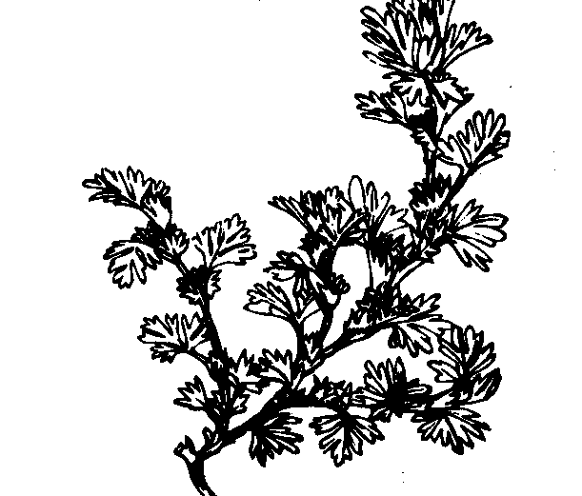

Parsley

Stuffed chicken
3½ lb (1.6kg) chicken
4 hard-boiled eggs
2 medium onions
½ pt (275 ml) chicken stock
1 small bunch of parsley
1-3 tbs (30-45 ml) lard
salt & pepper

Prepare the chicken for stuffing and for spit or oven roasting. Separate the egg whites and yolks. Slice the onions thinly. Bring the stock to the boil, and blanch the onions and parsley for 2-3 minutes. Remove the parsley and cook the onions until soft. Drain, reserving the remaining stock. Cool.

Cut off the parsley stalks and chop the leaves with the egg yolks, lard and seasoning. Add the onion. Stuff the chicken with the mixture, then truss it. Roast the chicken in the usual way, with the reserved stock in the drip tray or roasting tin. Use it to baste the chicken and to make a thin or slightly thickened gravy with the pan juices and some extra stock. If wished, garnish with the egg whites, chopped, and a little extra parsley.

Curd flan
‘Take nessh chese, and pare it clene, and grind hit in a morter small, and drawe yolkes and white of egges thorgh a streynour, and cast there-to, and grind hem togidre; then cast thereto honey, butter and salt, and put together in a coffyn of faire paast, and lete bake ynowe, and then serue it forthe.’

‘nessh chese’ is fresh soft curd cheese
‘coffyn of faire paast’ is a light pastry case.

Drawing courtesy of English Heritage
© The Landscape Research Centre 2003

FOOD & COOKING

IN ANGLO-SAXON

HESLERTON

